**CHAPTER-3**

**DESIGN AND IMPLEMENTATION OF SMART HOME IOT**

**USING MICRO CONTROLLERS**

**3.1. Overview of the System**

The project has three main parts,

* Reading sensor values and upload it on cloud
* Home security with fingerprint sensor and automating LEDs around the house.
* Controlling LEDs in the house from the Website

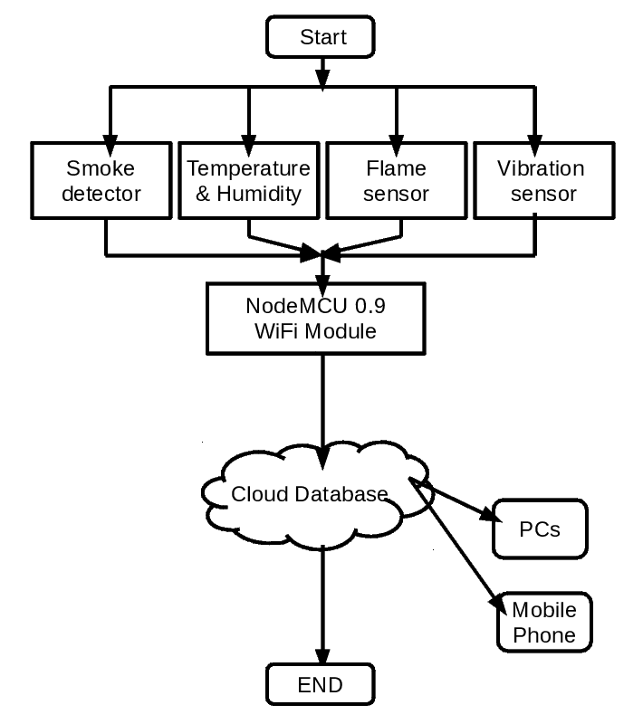

Figure 3.1 Flow Chart of Reading Sensor Values and Upload it on Cloud